**PROJECT REPORT**

**ON**

# DONATION MANAGEMENT SYSTEM

**SMT. P.N. DOSHI WOMEN’S COLLEGE, GHATKOPAR (W)**

**NAAC ACCREDITED ‘A’ GRADE (III CYCLE)**

**SHRI H.P. DOSHI & SHRI P.L. DOSHI DEPARTMENT OF**

**BACHELOR OF COMPUTER APPLICATIONS (BCA)**

**BY**

**Ms. SabreenCaudhari**

**Ms. Iqra Khan**

**Ms. Anjali Sahu**

**Ms. Neha Hisamullah**

**AFFILIATED TO**

**S.N.D.T. WOMEN’S UNIVERSITY, MUMBAI**

# 2021-2022

**Name of Internal Guide: Name of External Guide:**

**Ms. MinakshiNandgaonkar Ms. Shraddha Karande**

**Designation:** Assistant Professor  **Designation:** Assistant Professor

**PROJECT REPORT**

**ON**

# DONATION MANAGEMENT SYSTEM

**SMT. P.N. DOSHI WOMEN’S COLLEGE, GHATKOPAR (W)**

**NAAC ACCREDITED ‘A’ GRADE (III CYCLE)**

**SHRI H.P. DOSHI & SHRI P.L. DOSHI DEPARTMENT OF**

# BACHELOR OFCOMPUTER APPLICATIONS (BCA)



**BY**

**Ms. SabreenCaudhari**

**Ms. Iqra Khan**

**Ms. Anjali Sahu**

**Ms. Neha Hisamullah**

**AFFILIATED TO**

**S.N.D.T WOMEN’S UNIVERSITY, MUMBAI**

**2021-2022**

**CERTIFICATE**

This is to certify that Ms. __________________________has completed the project titled “**DONATION MANGEMENT SYSTEM”**satisfactorily and submitted the project report as per guidelines of the S.N.D.T. Women’s University, Mumbai.

**Head of Department Principal**

Signature: Signature:

Name: Dr.Suchita Bhovar Name: Dr.Asha Menon

Date: Date:

College Seal:

**Internal Examiner External Examiner**

Signature: Signature:

Name: Name:

Date: Date:

## **ORGANISATION**

## **INDEX**

|  |  |  |
| --- | --- | --- |
| **SR NO.** | **TOPIC NAME** | **PAGE NO.** |
| 1. | Acknowledgement | 06 |
| 2. | Declaration | 07 |
| 3. | Abstract | 08 |
| 4. | Introduction | 09 |
| 5. | Project Profile | 10 |
| 6. | Existing System | 11 |
| 7. | Proposed System | 12 |
| 8. | Feasibility Study | 13 |
| 9. | Data Flow Diagram | 14 |
| 10. | Entity Relationship Diagram | 16 |
| 11. | Data Dictionary | 17 |

# ACKNOWLEDGEMANT

I convey my sincere gratitude to our college Smt. P. N. Doshi Women’s College for giving me an opportunity to prepare my project work under the title “**Donation Management System**”.I express my sincere thanks to all the staff members of Department of Bachelor of Computer Applications (BCA). I am thankful to Internal guide Ms. Shraddha Karande and External guide Ms. MinakshiNandgaonkar for their guidance during my project work and sparing their valuable time for the same. I express my sincere obligation and thanks to all the faculties of the department for their valuable advice in guiding me at every stage in bringing out this report.

## **DECLARATION**

## I do hereby declare that this project work entitled “**Donation Management System**” submitted by me for the fulfilment of the requirement for the award of Bachelors in Computer Applications (BCA) is a record of my own research work. The report embodies the finding based on my study and observation and has not been submitted earlier for the award of any degree or diploma to any Institute or University.

## Date:

## **ABSTRACT**

This research work generally summarizes the activities carried out in the design and implementation of the “**Donation Management System”**. This Donation management is a non-profit organizational system in which non-governmental organization and donors can come in and request and donate funds and materials such as cloths, study materials, foods, hospital equipment, etc. These objectives are creating online payment, creating login and register page, letting them go through the funding and other donation system. The project’s design was then constructed to visualize the attainment of these aims using Data Dictionary, Entity Relationship diagram, as well as Data Flow Diagram. In the implementation part of this project, the methodology was used for the development of this project. Also Microsoft Visual Studio was used as a front end development with a C# language.

## **INTRODUCTION**

The **“Donation Management System”** is being developed for managing online donation process & organization named "SPRJ Kanyashala trust" based in Ghatkopar (W).

This project aims the creation of a secure internet donation system which is accessible to all the donors around the world as well as collection site for the trust.

The objective of this project is to develop a non-profit website for an organization’s onlinebased donation process where donors can donate from any corner of the world through Internet. It is a space where donors can browse all the details ofthe donation projects run under the organization & donate for it. After the successful donation on the website the donor will receive an automated donation/tax receipt with thank you message. Also organization can trace donor details & donation details through the database.

**PROJECT PROFILE**

**Front-End:** ASP.NET with C# ( HTML, CSS & JavaScript).

**Back-End:** Structured Query Language (SQL)

**Software Used:**

Front-End: Microsoft Visual Studio 2015

Back-End: SQL Server 2020

Documentation tool: Microsoft word 2016

**EXISTING SYSTEM**

In the existing system, all the donation is being done through cheque, NEFT & cash. The current website is in used only for sharing donation project details & for donation account details. Donation cheques are being received by the organization’s project in charge. NEFT donation are done by the donor to the account details present on the website & send it’s successful payment screen shot to the reference person for conformation. Donation in cash is received from the donor to its project in charge.

**PROBLEM AREAS:**

1. Online donation cannot be done directly from the website.
2. Donor has to wait for 1-2 days for his/her NEFT donation received/or not confirmation from the organization.
3. Organization doesn’t receive donor’s complete information at once.
4. Organization doesn’t has its universal database of donor’s details.
5. From donor side as well as organization side it’s time consuming process.

**PROPOSED SYSTEM**

In co-operation with the organization, our development group has proposed an updated version of the non-profit website for online donation process. In the proposed system, the donor can register/ login into the website by his/her mobile number & completing the registration by filling the on the page. On the website, all the project details would be available. While browsing, donor would be able to directly donate from the website itself & through different payment mode. After donating, the donor will receive automated donation/tax receipt with thank you message.

**ADVANTAGES:**

1. Donor will receive donation receipt on the spot.
2. Organization will receive donor’s complete information at once through the online form.
3. Donor can easily trace their donation details till date with the help of their profile.
4. Online donation can be done directly from the website.
5. Ease of access of data remotely 24/7.
6. No documentation needed.

**FEASIBILITY STUDY**

A feasibility study is an evaluation and analysis of the potential of the proposed project. It is based on extensive research and investigation to support the process of decision making,

There are 3 types of feasibility study:

**1. TECHNICAL STUDY:**

●This website is developed using Microsoft Visual Studio with C# language as the front end and SQL as the back end.

●So, to develop program logic, codes can be in many languages like HTML, CSS, JS, etc.

**2. OPERATIONAL STUDY:**

● People are inherently resistant to change, and computers have been known to facilitate change.

●An estimate should be made of how strong a reaction the user staff is likely to have towards the development of a computerized system.

●It is common knowledge that computer installations have something to do with turnover, transfers, retraining, and changes in employee job status.

**3. ECONOMICAL FEASIBILITY:**

● Economic feasibility analysis includes the cost of resources needed for development, analysis, etc.

●The development cost for the proposed system is minimum.

●It satisfies the organization’s requirements and can be used by anyone.

● No access to the Internet is needed. Since the project proposal has passed all three tests of feasibility, hence it can be judged to be a feasible project.

**DATA FLOW DIAGRAM**

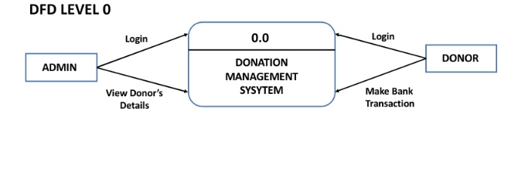

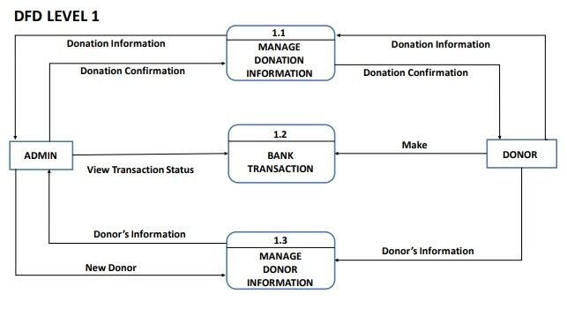

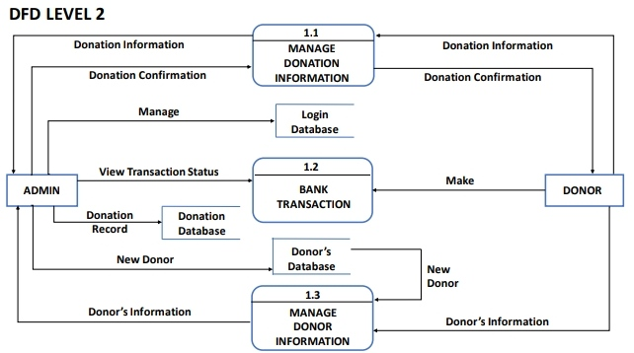

**ENTITY RELATIONSHIP DIAGRAM**

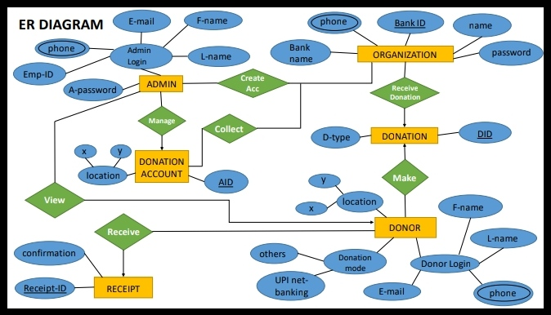

**DATA DICTIONARY**

1. **Entity: Admin**

|  |  |  |
| --- | --- | --- |
| **Field Name** | **Data Type** | **Description** |
| F-Name | Char (15) | Admin’s First Name |
| L-Name | Char (15) | Admin’s Last Name |
| E-mail | Varchar (15) | Admin’s E-mail ID |
| Phone | Int (10) | Admin’s phone number |
| Emp-ID | Varchar (10) | Admin’s user-id |
| Password | Varchar (10) | Admin’s password |

1. **Entity: Organization**

|  |  |  |
| --- | --- | --- |
| **Field Name** | **Data Type** | **Description** |
| Name | Char (15) | Organization’s name |
| Bank-ID | Int (20) | Organization’s bank-id |
| Bank Name | Char (30) | Organization’s bank name |
| Phone | Int (10) | Organization’s phone number |
| Password | Varchar (10) | Organization’s password |

1. **Entity: Donation**

|  |  |  |
| --- | --- | --- |
| **Field Name** | **Data Type** | **Description** |
| D-Type | Varchar (20) | Donation type |
| D-ID | int (15) | Donation id number |

1. **Entity: Receipt**

|  |  |  |
| --- | --- | --- |
| **Field Name** | **Data Type** | **Description** |
| Confirmation | Varchar (50) | Confirmation letter |
| Reciept-ID | Int (15) | Receipt confirmation id |

1. **Entity: Donation Account**

|  |  |  |
| --- | --- | --- |
| **Field Name** | **Data Type** | **Description** |
| Account-ID | Int (20) | Donation Account id |
| Location | Varchar (30) | Donation Account location |

1. **Entity: Donor**

|  |  |  |
| --- | --- | --- |
| **Field Name** | **Data Type** | **Description** |
| F-Name | Char (15) | Donor’s first name |
| L-Name | Char (15) | Donor’s last name |
| Phone | Int (10) | Donor’s phone number |
| E-mail | Varchar (15) | Donor’s E-mail id |
| UPI Net banking | Varchar(20) | Donor’s payment mode |
| Location | Varchar (30) | Donor’s location |